CREATE DATABASE rabba;

USE rabba;

CREATE TABLE project(

p_no INT,

p_name VARCHAR(20),

p_loc VARCHAR(20),

PRIMARY KEY(p_no)

);

CREATE TABLE dept(

dept_no INT,

d_name VARCHAR(20),

d_loc VARCHAR(20),

PRIMARY KEY(dept_no)

);

CREATE TABLE employee(

emp_no INT,

e_name VARCHAR(20),

mgr_no INT,

hire_date DATE,

sal INT,

dept_no INT,

PRIMARY KEY(emp_no),

FOREIGN KEY(dept_no) REFERENCES dept(dept_no) ON DELETE CASCADE

);

CREATE TABLE incentives(

emp_no INT,

incentive_date DATE,

incentive_amount INT,

PRIMARY KEY(emp_no,incentive_date),

FOREIGN KEY(emp_no) REFERENCES employee(emp_no) ON DELETE CASCADE

);

CREATE TABLE assigned_to(

emp_no INT,

p_no INT,

job_role VARCHAR(20),

PRIMARY KEY(emp_no,p_no),

FOREIGN KEY(emp_no) REFERENCES employee(emp_no) ON DELETE CASCADE,

FOREIGN KEY(p_no) REFERENCES project(p_no) ON DELETE CASCADE

);

INSERT INTO dept VALUES

("1","Railway","Bangalore"),

("2","Airways","Hyderabad"),

("3","Roadwys","Mysore"),

("4","Waterways","Andaman"),

("5","Drainage","Bombay"),

("6","Pollution","Delhi");

INSERT INTO project VALUES

("1","Lalbhagh","Bangalore"),

("2","Sarojini nagar","Delhi"),

("3","Tiruvananth","Chennai"),

("4","India gate","Bombay"),

("5","Presidency","Mangalore"),

("6","Church","Goa"),

("7","Pink","Jaipur"),

("8","Taj","Agra");

INSERT INTO employee VALUES

("10","HS","101",'2015-12-1',"25000","2"),

("11","MM","102",'2013-1-12',"10000","3"),

("12","SUHAS","12",'2013-10-20',"100000","6"),

("13","VISHWAS","141",'2021-3-23',"2200","5"),

("14","VINAYAK","12",'2019-9-15',"39000","1"),

("15","UJWAL","12",'2011-8-3',"70000","4"),

("16","SKANDA","007",'2021-5-6',"30000","1"),

("17","KARANJI","1007",'2016-4-13',"19000","2");

INSERT INTO incentives VALUES

("13",'2021-11-5',"2000"),

("11",'2019-1-21',"3000"),

("14",'2020-10-15',"9000"),

("15",'2015-11-15',"7000"),

("15",'2021-11-5',"1000");

INSERT INTO assigned_to VALUES

("10","2","Architect"),

("17","2","Civil Engineer"),

("11","3","Developer"),

("13","1","Android"),

("13","3","Website"),

("14","3","Financial"),

("15","6","Sales dept"),

("10","4","Team Head"),

("15","5","Testing"),

("14","1","Cloud"),

("11","7","Dev ops"),

("10","8","Data Science");

select * from project;

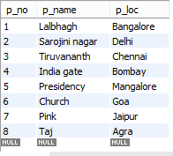

select * from dept;

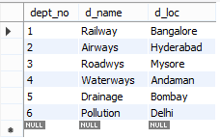

select * from employee;

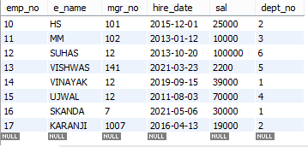

select * from incentives;

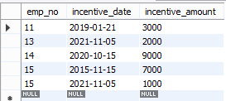

select * from assigned_to;

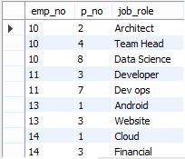

**QUERY 1**

SELECT DISTINCT e.emp_no,e.e_name

FROM employee e,assigned_to a,project p

WHERE e.emp_no=a.emp_no AND a.p_no=p.p_no AND p.p_loc IN("Bangalore","Bombay","Mysore");

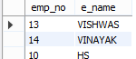

**QUERY 2**

SELECT DISTINCT e.emp_no

FROM employee e,incentives i

WHERE e.emp_no NOT IN(SELECT i.emp_no FROM incentives i);

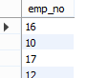

**QUERY 3**

SELECT DISTINCT e.e_name,e.emp_no,e.dept_no,a.job_role,d.d_loc,p.p_loc

FROM employee e,dept d,assigned_to a,project p

WHERE d.dept_no=e.dept_no AND e.emp_no=a.emp_no AND a.p_no=p.p_no AND p.p_loc=d.d_loc;

